Contents
1. Create a Long Service Scheme for accrual balances 3
A. Create an Accrual Balance and set parameters 4
1. Parameters 5
2. Affecting Codes (Accrual Balances) 6
3. Advanced Parameters (Accrual Balances) 6
4. Include Rest Days (Accrual Balances) 7
5. Accrual Codes (Accrual Balances) 8
6. Days of the Week (Accrual Balances) – Use default 8
7. MSS Parameters (Accrual Balances) 9
8. Configure the Accrual Calendar (Accrual Balances) 9
9. Configure the Balance Calendar (Accrual Balances) 10
10. Set Entitlements per Balance (Accrual Balances) 11
11. Set Balance pro rata configuration (Accrual Balances) 13
B. Create and configure Entitlement Balances 14
1. Create a Long Service Scheme for Entitlement Balances 14
2. Create a Holiday Scheme 16
3. Create a Balance 17
4. Parameters 18
5. Affecting Codes 19
6. Advanced Parameters 19
7. Advanced Pro Rata sub menu 21
8. Length of Service 22
9. Include Rest Days 23
10. Days of the Week 23
11. MSS Parameters 23
12. Configure the Balance Calendar 24
13. Apply the Balance Entitlement settings 25
14. Set Balance pro rata configuration 27

Document Version Control
Change History/Review Details
Date | Version | Review by | Summary of Change
 | 1.0 | TH | Initial draft provided by the WFM project.
06/05/22 | 2.0 | HC | Reconfigured guidance
05/10/23 | 3.0 | MOS | Include Entitlement Per Balance General Parameters
30/08/24 | 4.0 | MOS | Balance Parameters to include Rounding

Create a Long Service Scheme for accrual balances
This setting determines when employees receive extra annual leave days based on their length of service.

CoreTime/CoreRoster>System Parameters>Balances>Length of Service increments

NB: TAG have confirmed that this process will be moved to the Portal possibly in Q4 2022

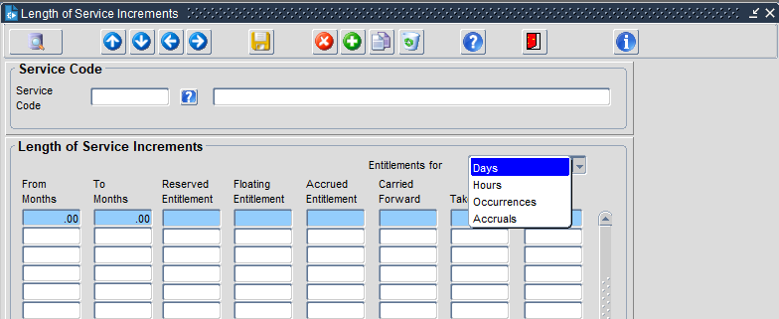

- Click on the LOV icon to view the current list of Long Service Codes, double check that the scheme you intend to create isn’t already there

- Enter a Service Code up to 6 characters in length.

- Enter a name for the scheme, following the naming convention of the existing schemes. E.G. LOSVH = long service scheme for Variable Hours Employees

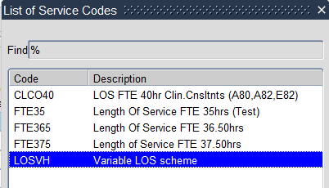

- SAVE.

- Under Length of Service Increments select ‘Accruals’ from the drop down list in the 'Entitlements for' box.

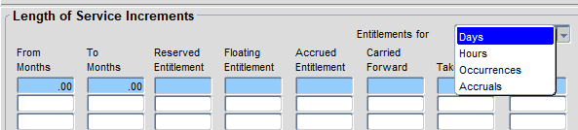

- Update as stated below:

Field | Description
From Months | Enter the minimum value
To Months | Enter the maximum value
Percentage | Enter the relevant percentage

 | NB: Each increment represents a stage in the long service scheme. The value recorded in the ‘Percentage’ column is the rate at which leave will be accrued.

 | NB: By default, the percentage leave is awarded at the start of the leave year during which the employee crosses the threshold (anniversary year). To award the additional leave at the start of the following leave year, increase the months by 12.

- SAVE.

Create an Accrual Balance and set parameters
Most of the Balances settings will be identical for all Accrual Balances, the settings which differentiate the Balances are highlighted.
NB: TAG have confirmed that this process is remaining in the Back Office

CoreTime/CoreRoster > System Parameters > Balances > Parameters

- Click on the LOV icon to view the current list of Balance codes, double check that the scheme you intend to create isn’t already there

- Enter a Service Code up to 6 characters in length.

- Enter a name for the scheme, following the naming convention of the existing schemes. E.G. LOSVH = long service scheme for Variable Hours Employees

- SAVE.

- Now work through each of the sub-menus as detailed below

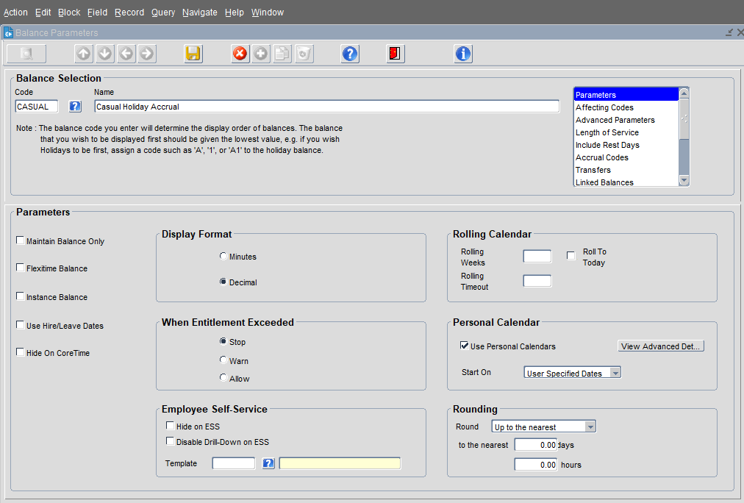

Parameters

  - Enter/select the details as specified below:
Field | Description
For ALL balances complete the fields below
Display Format | Decimal
When Entitlement Exceeded | Tick ALLOW for Balances following a universal leave year  Tick STOP for Balances following a personal calendar
For Balances following a personal calendar complete the additional fields below
Use Personal Calendars | Tick
Start on | Select ‘User Specified Dates’ from the list.

  - Leave all other settings as default

Affecting Codes (Accrual Balances)

  - In the selection box, choose ‘Affecting Codes'

  - Click into the first Row in the Pay Code column and select the relevant Holiday Pay Code from the list.
 | NB: When hours recorded against these codes are approved in timesheets, their value will be deducted from the amount accrued against the Balance

  - The ‘+/-’ column should default to ‘+’ and the ‘Multiplier’ should default to ‘1.00’

  - In the ‘Affecting Element' column, select ‘Taken’

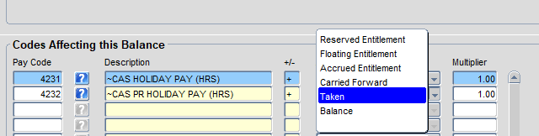

  - Repeat for each holiday code to be added

Advanced Parameters (Accrual Balances)

  - In the selection box, choose ‘Advanced parameters'
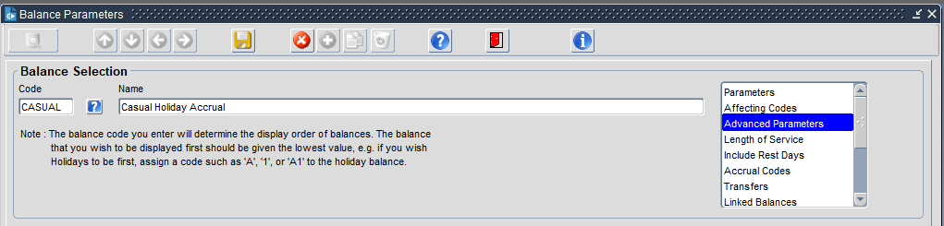

  - Under Advanced Parameters Auto Entitlement complete the following:

    - Tick ‘Populate Position History Details from CoreHR’

    - Tick ‘Calculate Entitlement Based On Position History’

    - In the ‘Entitlement Based On’ field, select ‘Company’ from the drop down list

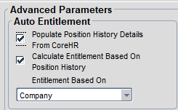

    - Under Multi-Appointment complete the following:

- Tick ‘Apply Appointment Id’

- Tick ‘Appointment Id Mandatory’

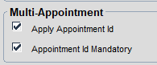

    - Retain all other default settings (as shown)

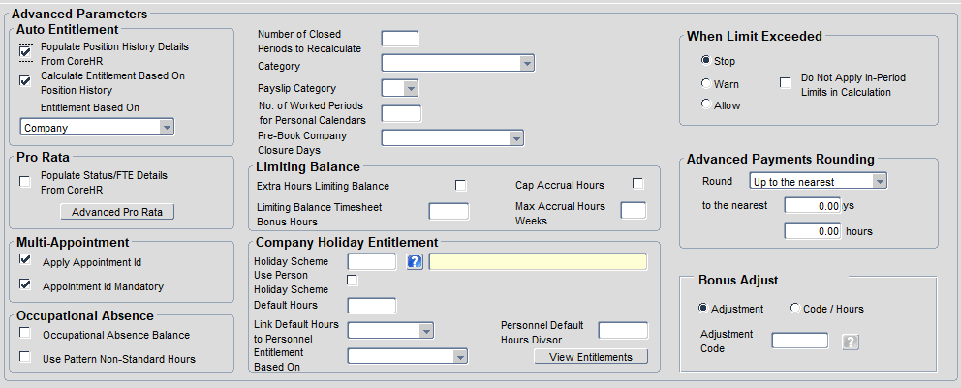

Include Rest Days (Accrual Balances)

  - Keep default settings (as shown)

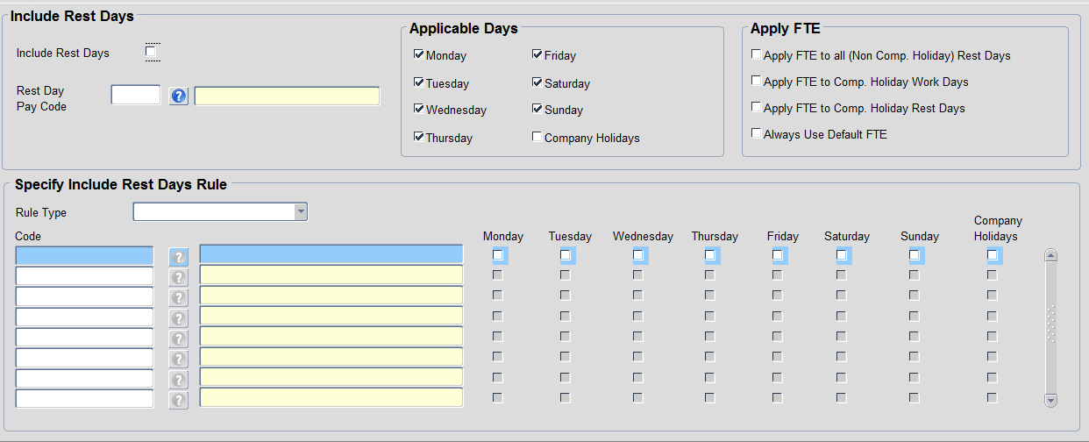

Accrual Codes (Accrual Balances)

  - Select the relevant Holiday Pay Code from the LOV.

When hours recorded against these codes are approved in timesheets, their value will be deducted from the amount accrued against the Balance.

  - The ‘+/-’ column should default to ‘+’ and the ‘Multiplier’ should default to ‘1.00’

  - Repeat for any further Holiday Pay Codes.

Days of the Week (Accrual Balances) – Use default

  - Keep default settings (as shown)

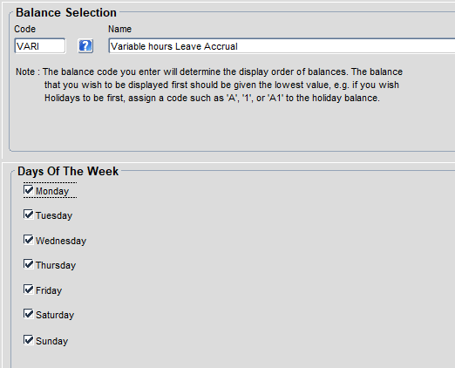

MSS Parameters (Accrual Balances)
This places the balance in the balance view in manager dashboard and should be applied to all annual leave.

  - Select ‘Annual Leave’ from the LOV

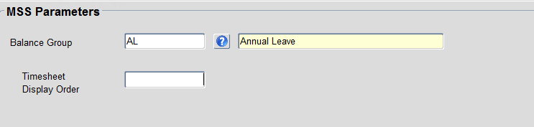

  - SAVE.

Configure the Accrual Calendar (Accrual Balances)
CoreTime/CoreRoster>System Parameters>Balances>Accrual Calendar

The Accrual Calendar determines the % of leave that will be accrued for any hours worked (before any long service increases)

Field | Description
Start date | For Accrual Balances following a Personal Calendar enter 01-JAN-2021  For Accrual Balances following universal leave year, enter the start date of the current leave year, e.g. 01-OCT-2021
End Date | For Accrual Balances following a Personal Calendar enter 31-DEC-2065  For Accrual Balances following universal leave year, enter the end date of the current leave year, e.g. 30-09-2022
% Accrual | enter the percentage at which leave is accrued (before any long service increase)
Hours - Min | 0
Hours – Max | 9999
Affect | +

  - For Accrual Balances following a universal leave year, repeat the above steps for future leave years and maintain moving forward

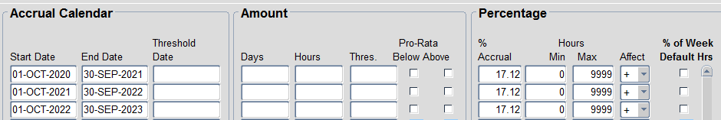

  - SAVE.

Configure the Balance Calendar (Accrual Balances)
NB: TAG have confirmed that this process is remaining in the Back Office

Each Balance has its own Balance Calendar. The Balance Calendar determines the Balance periods and the rules surrounding carrying forward leave from one leave year to the next.

CoreTime/CoreRoster > System Parameters > Balances > Calendar

  - Select the Balance you have just created from the LOV

  - Check that Controls for shows ‘Carried Forward’ or select ‘Carried Forward’ from the drop down list.

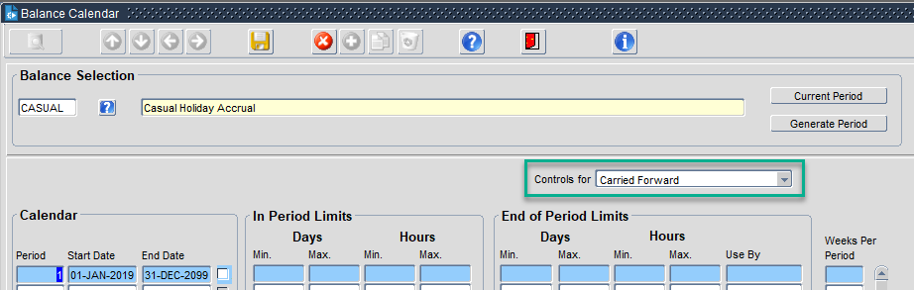

  - Click on the first available row

 | NB: The information you enter depends on whether the Balance follows a universal leave year or a personal one.

  - Update as shown below:

Section/Column | Universal leave year | Personal leave year
Calendar
Period | The year that the current leave year began. | 1
Start Date | The date the leave year begins as DD-MMM-YYYY e.g. 01-OCT-2021 | 01-JAN-2019
End Date | The date the leave year ends as DD-MMM-YYYY e.g. 30-SEP-2022 | 31-DEC-2099
End of Period Limits
Days – Min | Leave blank | Leave blank
Days – Max | Enter ‘0’ | Leave blank
Hours – Min | Enter ‘0’ | Leave blank
Hours – Max | Enter ‘0’ | Leave blank
Use By | Leave blank | Leave blank
Weeks Per Period | Leave blank | Leave blank

  - For Balances following a Universal leave year, add further rows covering future periods/leave years to match other balances created.

 | NB: For Balances following a Universal leave year a minimum of two future years should be maintained.  Balances following a Personal Calendar only need 1 period

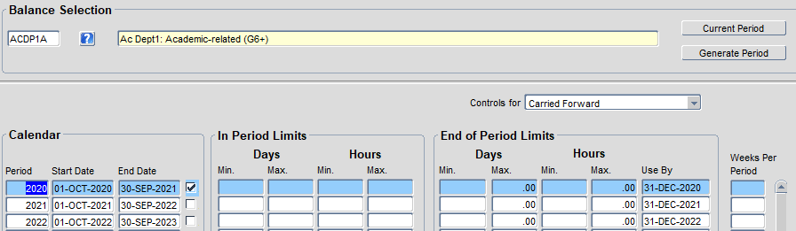

  - SAVE.

Set Entitlements per Balance (Accrual Balances)
Each Balance period needs its own set of Balance Entitlements. For Accrual Balances, the Balance Entitlements are simple to configure, as they do not interact with Holiday Schemes and the amount of leave accrued is determined elsewhere by the Accrual Calendar.

NB: TAG have confirmed that this process is remaining in the Back Office

CoreTime/CoreRoster > System Parameters > Balances > Entitlements per Balance

  - Select the Balance you are updating from the LOV

  - Check you are viewing ‘Balance Entitlements’

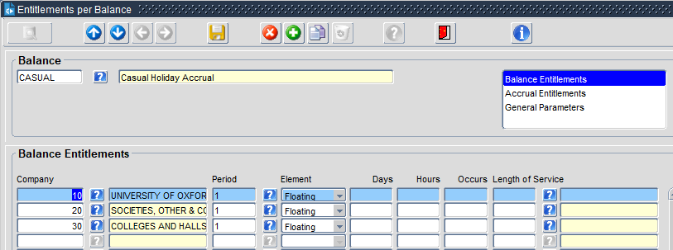

  - Click into the next available row

  - Repeat the following steps for each Company to be added:

Field | Description
Company | Select the Company from the LOV
Period | - For personal leave years, choose Period 1  - For universal leave years, choose the first available period
Element | Floating
Length of Service | If you are configuring a Balance which follows a universal leave year AND you wish to connect a length of service scheme to the Balance, select the relevant Length of Service Scheme

  - SAVE.

 | NB: According to The Access Group there is no need to repeat this exercise. It will pick up the last period and apply it to the next calendar.

Set Balance pro rata configuration (Accrual Balances)
Each Balance needs its own set of Pro Rata Details. These control the way the

NB: TAG have confirmed that this process will be moved to the Portal possibly in Q4 2022

CoreTime/CoreRoster > System Parameters > Balances > Pro Rata Entitlements

  - Click on the green + button to insert a new row (the system will sort the rows by Balance Code once you have saved and exited the record.

  - Repeat the following steps for each ‘Employee Status’:

Field | Description
Balance Code | Select from the LOV
Employee Status | Select from the LOV
Pro Rata Leave Date | Yes

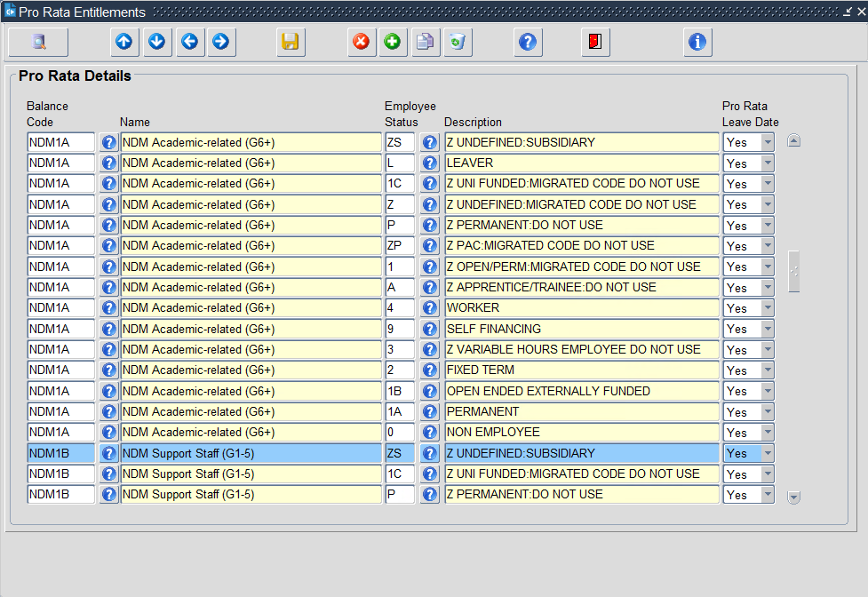
Pro Rata Details for Balance NDM1A

  - SAVE.

Create and configure Entitlement Balances

Create a Long Service Scheme for Entitlement Balances
A Long Service Scheme can be linked to a Balance, but this is optional and Balances will function without a scheme.
A single Long Service Scheme can be linked to multiple Balances which have:
- Different Holiday Schemes
- Different leave years
- Different base entitlement

All Balances linked to a Long Service Scheme must share the same:
- Long service entitlement and associated rules
- FTE hours

CoreTime/CoreRoster>System Parameters>Balances>Length of Service increments

NB: TAG have confirmed that this process is remaining in the Back Office

  - Click on the LOV to view current schemes and check that the one you intend to create isn’t already there.

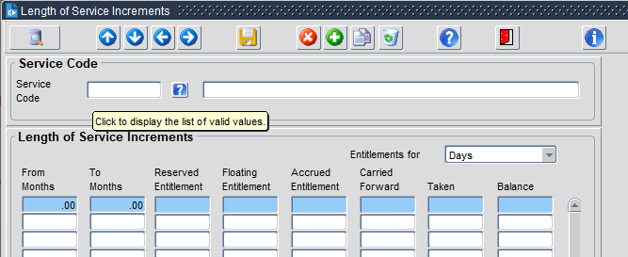

  - Enter a unique Service Code (Max 6 characters) and Description. Ensure you include the FTE Hours.

 | NB: Ensure you follow the naming convention of the existing schemes. Refer to xx document

  - SAVE.

  - Enter the details as follows:
Field | Description
Entitlements for | Days
From Months | Entitlement period start in months
To Months | Entitlement period end in months. On the final row enter 9999
Floating entitlement | Number of days to be awarded based on the criteria entered (usually 0 or 1).

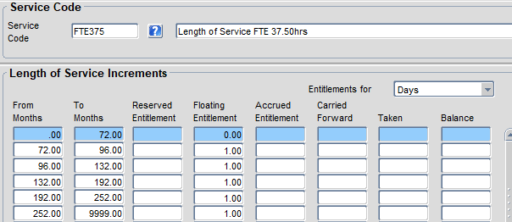

  - Amend the ‘Entitlements for’ to show ‘Hours’.

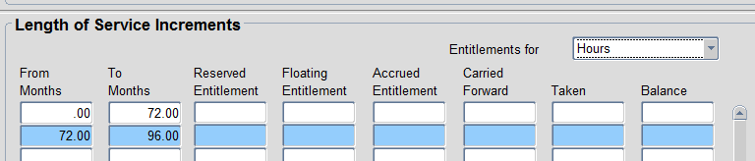

  - The ‘From/To’ months should already be complete, but you need to enter the ‘Floating entitlement’ in hours. The hours should reflect a standard day at this FTE (the weekly hours divided by 5)

For example, an FTE of 35 hours would result in a floating entitlement of 7.

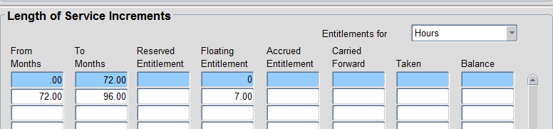

 | NB: Always enter the full-time equivalent hours. The system will perform a pro rata calculation on the floating entitlement for part-time appointments, regardless of whether the Balance is deployed in days or hours.

  - SAVE

Create a Holiday Scheme
 | NB: There is also a separate guide entitled ‘HOW TO - Update Holiday Schemes’ for updating existing Holiday Schemes as part of the annual Time maintenance tasks.

Company Holiday Schemes
CoreTime/CoreRoster>System Parameters > Holiday Schemes > Company Holiday Schemes

  - In the next available row, enter a unique code for your Holiday Scheme (Max 6 characters).

  - Enter a Description.

  - SAVE

Company Holiday Details
CoreTime/CoreRoster > System Parameters > Holiday Schemes > Company Holiday Details

  - Select the Holiday scheme you wish to edit from the LOV

  - Ensure the default ‘General-1’ tab is displayed.

  - Enter a new row for each public holiday or fixed closure day as follows:
Field | Description
Holiday Date | Enter in the format DD-MMM-YYYY or click on the LOV to select
Pay Code | Click on the LOV to select as follows:  - ‘PUBLIC HOLIDAY’ for all bank/public holidays  - ‘FIXED CLOSURE DAY’ for all departmental closure days, (e.g. the days between Christmas and New Year
Calc | Tick
Apply Hours | All (default)

  - SAVE

Create a Balance
Define the Balance Name & Balance Code
Insert something here

Create a Balance record and set parameters
There are a large number of settings which can be controlled within a Balance, but most are not relevant to the University of Oxford configuration, or will be the same across all entitlement Balances. The settings which differentiate the University’s Entitlement Balances are highlighted.

CoreTime/CoreRoster > System Parameters > Balances > Parameters

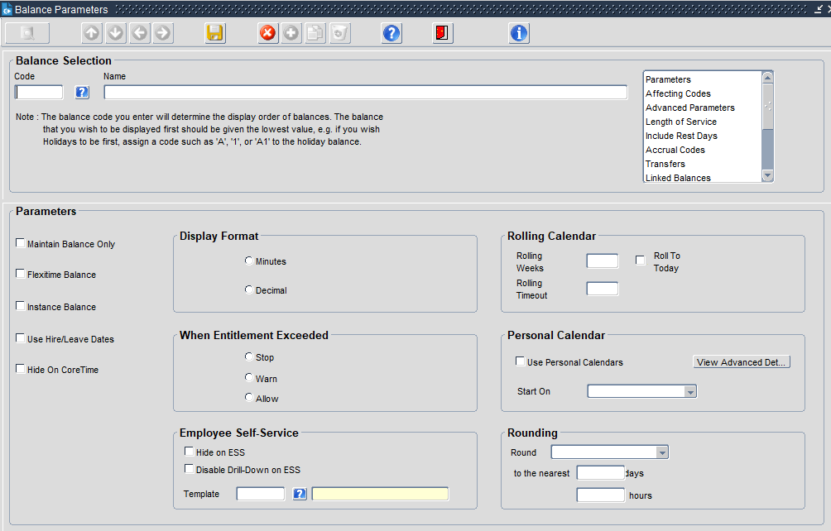

  - Use the LOV to view the existing balances and check that the Balance you intend to create isn’t already there

  - Enter a Balance code for the new Balance (see previous section on choosing a code)

  - Enter a Balance name (see previous section on choosing a name)

  - SAVE

  - Now work through each of the sub-menus

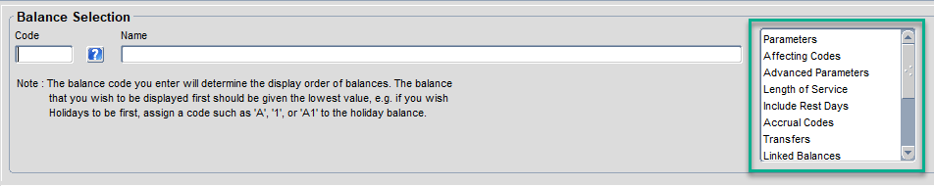

Parameters

  - Set ‘Display Format’ to ‘Decimal’

  - Set ‘When Entitlement Exceeded’ to ‘Stop'

  - Set Rounding ‘to the nearest’ to 0.50 days/hours.

  - Leave all other settings as default (see screenshot)

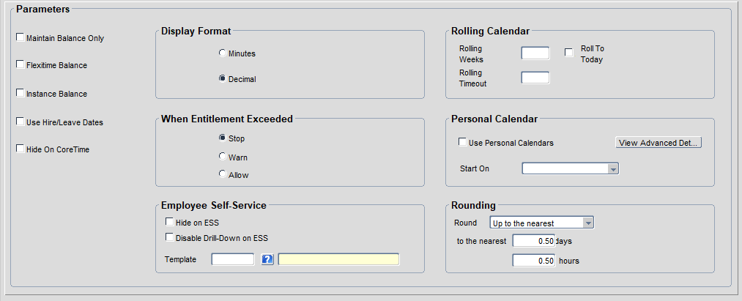
  - Enter/select the details as specified below:
Field | Description
For ALL balances complete the fields below
Display Format | Decimal
When Entitlement Exceeded | Tick ALLOW for Balances following a universal leave year  Tick STOP for Balances following a personal calendar
For Balances following a personal calendar complete the additional fields below
Use Personal Calendars | Tick
Start on | Select ‘User Specified Dates’ from the list.

  - Leave all other settings as default

Affecting Codes

  - In the selection box, choose ‘Affecting Codes'

  - Click into the first Row in the Pay Code column and select Annual Leave Pay Code (3991) from the LOV

  - The ‘+/-’ column should default to ‘+’

  - Under ‘Affecting Entitlement’ select ‘Taken’ from the drop down list

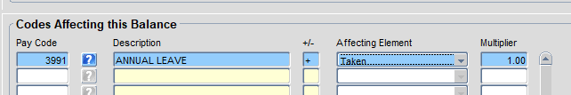

  - The ‘Multiplier’ should default to ‘1.00’

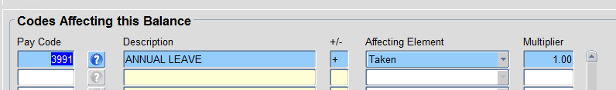

 | NB: This setting ensures that the leave entitlement is reduced when annual leave is booked.

Advanced Parameters

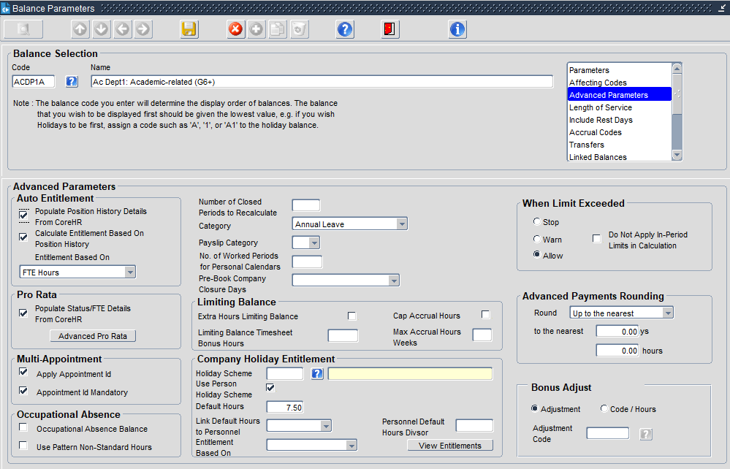

  - In the selection box, choose ‘Advanced parameters'



- Under Advanced Parameters Auto Entitlement complete the following:  - Tick ‘Populate Position History Details from CoreHR’  - Tick ‘Calculate Entitlement Based On Position History’  - Under ‘Entitlement Based On’ select ‘FTE Hours’ from the LOV | 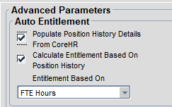
- Under Pro Rata Tick ‘Populate Status/FTE Details From CoreHR’ | 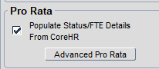
- Under Multi-Appointment complete the following:  - Tick ‘Apply Appointment Id’  - Tick ‘Appointment Id Mandatory’ | 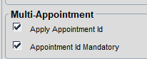

Advanced Pro Rata sub menu

  - Return to the Pro Rata section and click on ‘Advanced Pro Rata’ to open the sub-menu

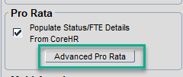

  - Enter/select as follows:
Field | Description
Adjustment Type | Select ‘Holiday’ from the LOV
Always Use Default FTE | Tick
Apply Target End Date | Tick
Pro Rata Starting Entitlements | Tick

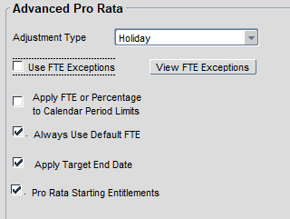

  - Leave all other settings as default

  - SAVE and click ‘OK’ to return the Advanced Parameters menu

- If you wish to associate the balance with a Holiday Scheme, within the ‘Company Holiday Entitlement’ section:
- Click on the ‘?’ icon next to ‘Holiday Scheme’ to select the appropriate scheme.
- In the ‘Holiday Scheme Default Hours’ field, enter the daily FTE Hours
for example, FTE Hours = 37.5 enter 7.5 hours

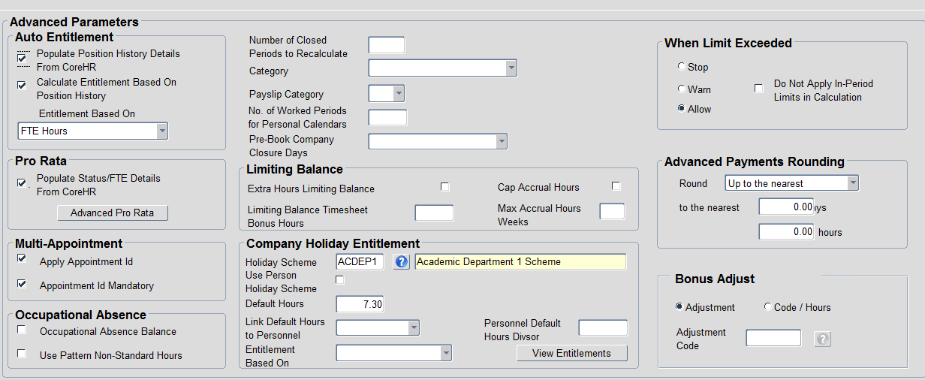

Note: The Company Holiday Entitlement section contains the ‘Link Default Hours to Personnel’ option, which, if activated, may negate the need for separate Balances purely to cater for FTE differences.

Length of Service
To associate a Length of Service Scheme with the balance, follow these steps, otherwise move on to section 3.9 ‘Include Rest Days’.

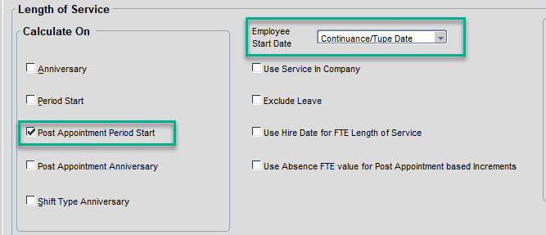

  - Under the ‘Calculate On’ section, tick ‘Post Appointment Period Start’

  - Set the ‘Employee Start Date’ to ‘Continuance/TUPE Date’.

Include Rest Days

  - Keep default settings (as shown)


Days of the Week

  - Keep default settings (as shown)

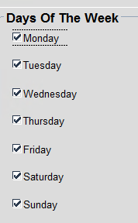

MSS Parameters

  - In 'Balance Group' select ‘AL - Annual Leave’ from the LOV.



Query timesheet display order? In the examples I looked at it is set to 1

  - SAVE.

Configure the Balance Calendar
You may find it useful to refer to the guide - HOW TO - Update Holiday Schemes v1.1.docx

CoreTime/CoreRoster > System Parameters > Balances > Calendars

  - In the LOV select the Balance you have just created

  - Check you are viewing Controls for ‘Carried Forward’. If not, select it from the drop down list.

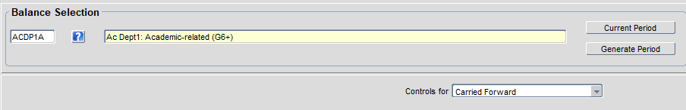

  - Click in the first available row and enter details of the leave year as per the table below:

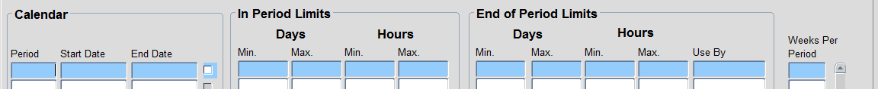

Field | Description
Calendar
Period | The year that the current leave year began.  For example, ‘2020’ if creating this balance for the Standard University leave year running Oct 2020 – Sept 2021.
Start Date | The date the leave year begins, format DD-MMM-YYYY. e.g. 01-OCT-2021
End Date | The date the leave year ends, format DD-MMM-YYYY. e.g. 30-SEP-2022
In Period Limits
Days Min & Max, Hours Min & Max | Leave all columns blank
End of Period Limits
Days – Min | Leave blank
Days – Max | Enter ‘0’
Hours – Min | Leave blank
Hours – Max | Enter ‘0’
Use By | For standard university leave year - The 31st of December in the year that the leave year began (the year recorded in the Period column). Format DD-MMM-YYYY. E.g. 31-DEC-2020.  Check carried forward deadline policy regarding non-standard leave years
Weeks Per Period | Leave blank

  - Repeat the above steps to add future leave years (minimum 2 future years or to match other balances)

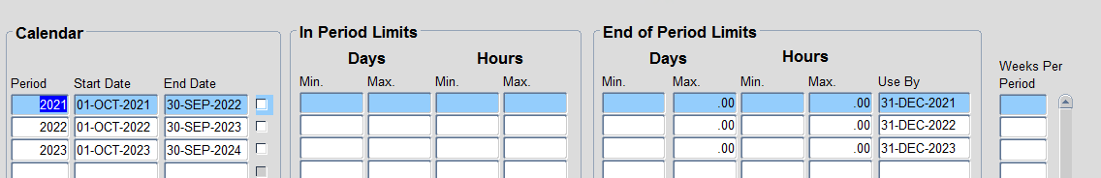

  - SAVE.

Apply the Balance Entitlement settings
CoreTime/CoreRoster>System Parameters>Balances>Entitlements per Balance

  - Select the Balance you are updating from the LOV.

  - Check you are viewing the ‘Balance Entitlements’ section

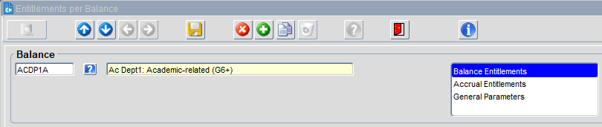

  - Click on the green + in the menu

Field | Description
FTE Hours | Select the relevant FTE hours from the LOV
Period | Select the first period from the LOV  (these were created earlier in the Balance Calendar step)
Days | Enter the number of floating days  (see earlier section for guidance on calculating the floating days)
Hours | Enter the equivalent in value in hours (calculated by multiplying the value entered for ‘Days’ by the daily FTE Hours
Occurs | Leave blank
Length of Service | Select the appropriate Length of Service scheme from the LOV  NB: The scheme must match the value you recorded in ‘FTE Hours’ column.

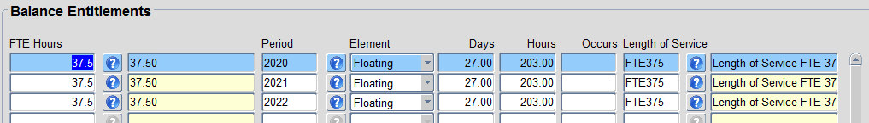

  - SAVE.

  - Select the General Parameters option from the drop-down selection list.

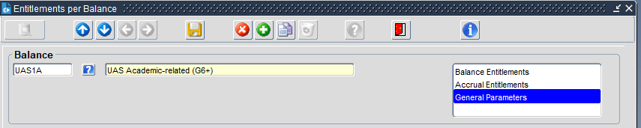

  - Ensure the ‘Calculate Service on Time in Company’ is ticked for the current period. The period should pull through from the Balance Calendar. It is recommended to tick future periods in the listing.

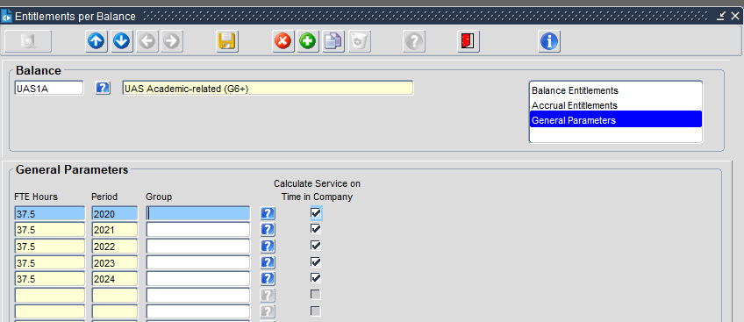

  - SAVE.

Note: extra steps may be required if using the FTE Hours by appointment setting, as a set of Balance Entitlements will need to be created for each FTE Hours variant covered by the balance.

Set Balance pro rata configuration
Each Balance needs its own set of Pro Rata Details setup per individual Employee Status.

CoreTime/CoreRoster > System Parameters > Balances > Pro Rata Entitlements

  - Click on the green + to insert a new row.

  - Click on the LOV under ‘Balance Code’ to select your Balance

  - Click on the LOV under ‘Employee Status’ and select the first employee status type in the drop down

  - Set the ‘Pro Rata Leave Date’ column to ‘Yes’

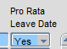

  - Repeat the above steps for each Employee Status.

  - SAVE


Pro Rata Details for Balance NDM1A

